[Curried Soba Noodles](http://www.thefitcook.net/home/curried-soba-noodles)

5/25/2011

[0 Comments](http://www.thefitcook.net/home/curried-soba-noodles#comments)

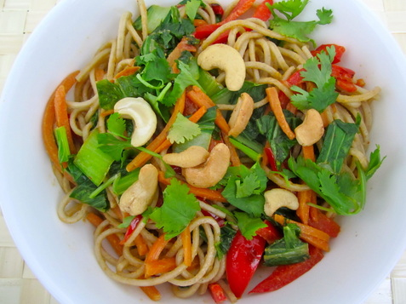

Curried Soba Noodles  
It's not hard to stay on track when you figure out the tiny tricks that make a really big difference. Curry dishes are usually rich and creamy - delicious, yes, but healthy, not so much! The reason for this is the coconut milk. Even when you go for the light version, 1/4 cup has 3 grams of saturated fat -- that's not the kind you want to be eating. I found a little way around it.

[Share](http://www.addthis.com/bookmark.php?v=250&pubid=xa-4ddd47430eb1d4ed)|

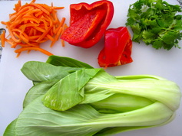

***You'll Need:***  
***serves 2***  
  
4 oz Japanese Soba Noodles (buckwheat)  
1/2 cup matchstick carrots  
1 red bell pepper, thinly sliced  
1 cup bok choy, chopped  
1/4 cup light coconut milk  
1 tsp curry paste  
1 tsp fish sauce (or soy)  
1/4 cup fresh cilantro, chopped  
1/4 cup cashews, chopped  
olive oil  
salt + pepper

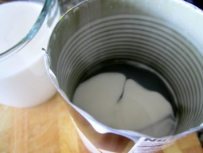

***Here's How:***  
  
1. Bring a pot of salted water to a boil for the noodles. Cook the noodles according to package instructions. When it is al dente, drain and set it aside. (In place of the Soba noodles, you can use regular whole wheat pasta.)  
  
2. Meanwhile, preheat 1 tbsp olive oil in a large skillet over medium-high heat. Add the carrots and red bell pepper, and cook for 3-5 minutes, or until soft. Add the bok choy, and cook for about 2 more minutes, or until it wilts. Add the curry paste to the veggies and stir.   
  
3. Time for the coconut milk - Step 1: Don't shake the can, even if it tells you to. Most of the oil is sitting at the bottom, while the white liquid rests on top. Step 2: Very carefully open the can and gently pour the white liquid into a separate measuring cup or mug, leaving the clear substance at the bottom of the can - discard that. Pour 1/4 cup of the white coconut milk into the skillet with the veggies, plus the fish sauce, and stir.  
  
4. Add the noodles to the skillet and toss until they are coated. Serve - top with cilantro and chopped cashews.  
  
***Notes:***  
1. Feel free to add grilled chicken or shrimp to this dish, but keep in mind the noodles have 8 grams of protein per serving.  
2. Add more veggies - snap peas, green bell pepper, chopped shallots and many others would work here.